TC-DVA-008
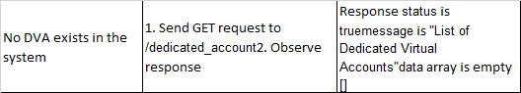
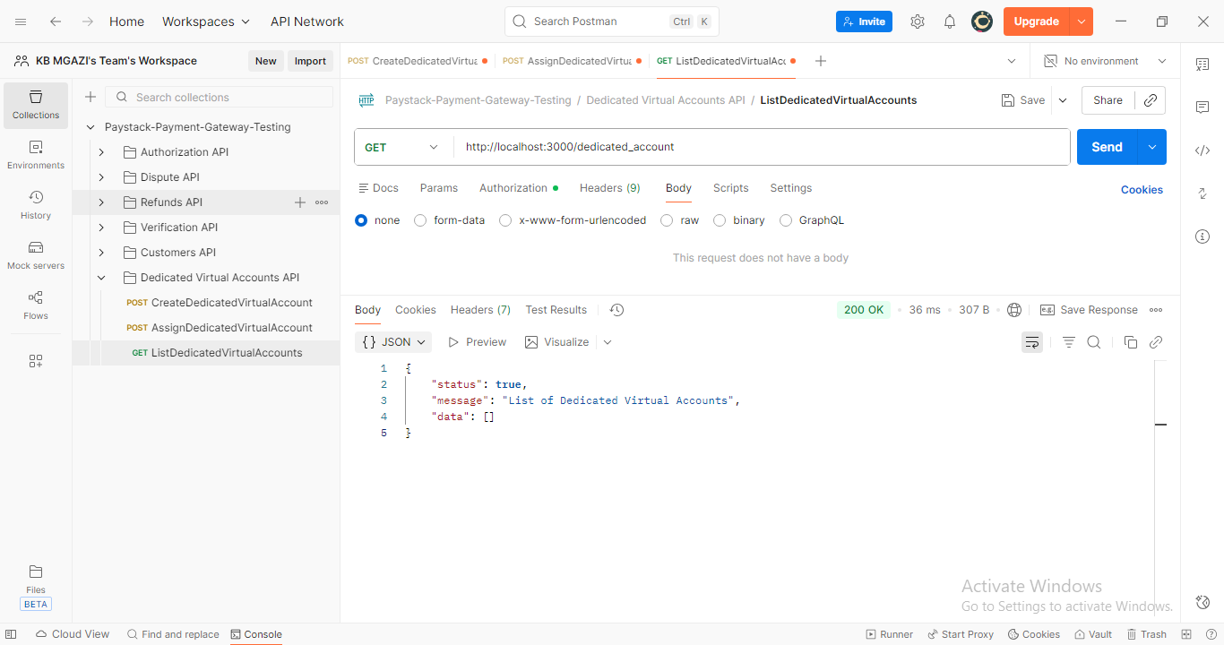
Response:
{
"status": true,
"message": "List of Dedicated Virtual Accounts",
"data": []
}

